How to Check Your Coil Threads after a Coil Fit
Patient Information Leaflet
Copper Coil or Hormonal Coil (Mirena or Jaydess)

Checking your coil threads

There are two threads attached to the bottom of your IUD (intrauterine device) that come down the womb and out of the cervix (neck of the womb). When in place they sit high up in the vaginal canal. These threads allow you to check that your coil remains in place. They are also there so that your doctor can remove your IUD at a later date.
Your IUD may stop working if it slips either partially or completely out of place (known as expulsion). You may not experience any symptoms if this happens, therefore it’s important to check the threads regularly. Occasionally the threads can also curl up within the womb itself.
How to check your coil threads:

- Wash your hands
- Either sit or squat
- Insert your index or middle finger into your vagina until you touch the cervix (which should feel like the tip of your nose)
- If you can feel both the IUD threads then your IUD is in place. The threads will feel like fishing line.
- If the IUD threads feel longer or shorter than the last time you checked, or you cannot feel them at all, then your IUD may have moved.
When should I check my IUD threads?

The best time to check your IUD threads is at the end of each period as the cervix will be lowest in the vaginal canal at this point of your menstrual cycle.
It is particularly important to check your IUD every four weeks after fitting. If your IUD is going to move out of place it will most likely do so in the first few months after it has been inserted.
If you can’t feel your IUD threads you should check your pads/tampons/menstrual cup to ensure that it has not come out. After this initial period, you should check your IUD threads every few months.

What should I do if I think my IUD has moved?

If your IUD has moved it will need to be put back in place by a doctor or the coil may have to be replaced. DO NOT try to push the IUD back up into place.

Contact your GP practice to make a follow up appointment with a nurse or doctor for an internal examination. You may require an ultrasound or abdominal X-ray to locate the coil if it is not visualised during the examination.

Until you can get to a doctor or nurse, make sure that you use a backup contraception, like a condom.
You may choose to have the IUD threads cut shorter if they can be felt by your sexual partner, however, this will obviously make it more difficult for you to check them.

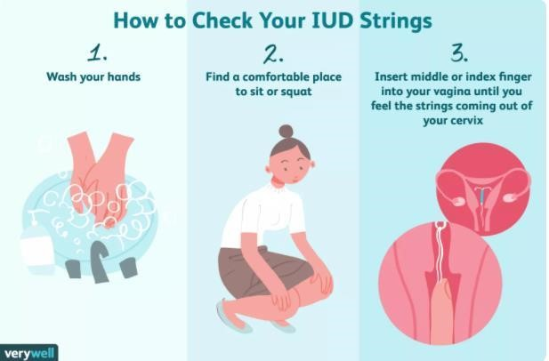

Source: https://www.verywellhealth.com/how-to-check-your-iud-strings-906659#:~:text=When%20checking%20your%20IUD%20strings,be%20coming%20through%20your%20cervix

Wassand Close, Three Bridges, Crawley, West Sussex. RH10 1LL
01293 526025
www.bridgemedicalcentre.co.uk
www.nhs.uk

